The
Transformation
of
Henry Meeker
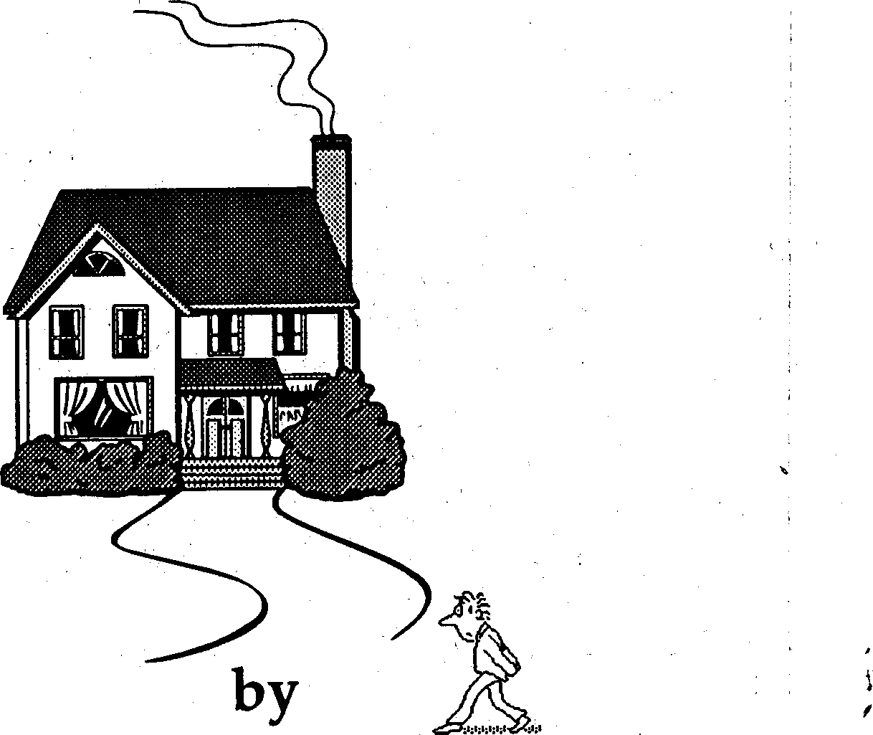
Allison Chase Sutherland

A stout woman in a tight-fitting red print dress strode deliberately up the walk of 5 Maple Lane and firmly pressed the buzzer of the door. She stepped back a moment, cleared her throat, and glanced at her watch – five o'clock. She pulled off her gloves, dropped them in her over-sized purse, and clapping it shut, tossed a glance up the street. No one. Then with a scoff and a grumble, she raised a temperamental fist to the screen door and bellowed, "Henry Meeker, don't tell me you're not here!"
She exhaled in annoyance and started fumbling through her purse until she produced the key to the little stone house at 5 Maple Lane, and then she let herself in, for she was Amanda Louise Meeker.
At approximately 5:15 that same breezy late October afternoon, a rather frail-looking little man in an over-sized gray suit and an over-sized gray hat came striding hastily up that same concrete walk, clutching an old brown briefcase in his arms. His thin lips set in determination, he stretched his bow-tied neck forward as he walked, when he tripped over a break in the leaf-scattered walk. His horn-rimmed glasses slipped off the end of his nose and he grabbed at his forehead, when his briefcase dropped open, spilling his orders to the ground. He fell to his knees and groped over the leaves to retrieve his glasses. Replacing them firmly on his face, he readjusted the strands of wispy light-red hair on his forehead and began to hurriedly gather up the papers strewn about the yard.

"Is that you Henry?" roared the voice at the door of the little house at 5 Maple Lane. "Well it's about time! I've been waiting here now for over a quarter of an hour. It just better not be like this every Tuesday."
"Oh, hello, Mother, I'm really dreadfully sorry" stammered Henry Meeker, glancing up at his mother. "I took the 5:05 bus from town, as I always do," he explained, "and I hurried the whole way home," he added, smiling apologetically. His mother did an about-face, and stormed into the little stone house, leaving Henry out in the yard to chase his blowing papers into the street. When he had collected them all, he hugged his broken briefcase closed, and ducked into the room with his mother.
And this familiar scene was once again witnessed by Ruth Esther Perkins and her sister Emma from the tearoom of their little stone house at 3 Maple Lane.
"Tch, tch, tch, what a shame, that poor boy. He's such a nice young man, but what a pitiful state he's in," sighed Emma. Perkins, wringing a monogrammed handkerchief in her soft, pudgy hands.

"Well, Emma, you know, you're absolutely right. It's quite a pickle, it is, and it's all because of that mammy o' his, if I do say so myself!" asserted the the wiry Ruth Perkins.
"I must agree, most assuredly, Ruth, and it is most distressing," said Emma, taking a sip of tea, and then wiping the lipstick from the rim of the cup.
"Emma, this has gone far enough, I say, and we must put a stop to it," insisted Ruth, banging a small fist on the arm of her chair.
"Oh, but Ruth Esther, who? Us?" queried Emma. "What on earth could two old sit-abouts possibly..."
"Emma, who you callin' a sit-about? First woman to drive a motorcar in all of Dickenson County? People used to pull off the side of the road and hop right out when I went by. 'Why that's a woman drivin',' they'd say"
"Why, it was you Ruth," said Emma.
"And that's what I'm a'sayin', Emma. We're Perkins, we are, and when we see something that ain't fittin', we fix it. And this here situation most certainly ain't fittin'!" Ruth Esther inhaled slowly from her cigarette.
Emma paused, and then asked, "But Ruth Esther, what could we possibly do?"
Now Ruth paused a moment with her head tilted back, and said to Emma, "I'm gonna set back and think on that a spell, Emma, if you don't mind." And she leaned back deep into her chair and she did just that.
Emma poured herself a cup of camomile tea and wrapped her jewelled hands around the warm porcelain. The sun was low in the sky now, and the evening chill of autumn was setting in. The dry leaves scratched across the sidewalk, and more colorful leaves fell from the branches. The screen door of the little stone house at 5 Maple Lane squeaked open and out stepped the robust woman in red.
Ruth Esther and Emma Perkins turned their hidden gaze toward her and followed her with their eyes down Maple Lane until she turned down Blackwood Road. Emma looked toward Ruth Esther to learn the result of her ponderings. Ruth Esther's eyes seemed to be fixed upon a certain point in the yard, and she wore a puzzled expression. Just as Emma was about to inquire as to what she was thinking, Ruth Esther Perkins spoke.
"Emma, do you see what I see?" she said.
"What, Ruth, what?" exclaimed Emma, in surprise.
"Emma, do you see that white slip of paper under the pink dogwood?"
She adjusted her bifocals and tried to discern the sheet of paper from the growing darkness. "Why, I don't believe I do, Ruth Esther, but..."
"I was just thinking, Emmy. Remember this afternoon when Mr. Meeker returned from work?" she said slowly. I think I'm gonna go see what that piece of paper is," she added decidedly. She reached for her shawl and wrapped it about her tiny frame.
"Oh, for heaven's sakes, Ruth Esther, can't it wait until morning. Don't go out there in the dark." But Ruth Esther was soon stooping down under the pink dogwood and returned shortly with the evidence: a slip of ordinary business stationery from Gray's Stationery Company. Typed unpretentiously down the left side of the page was a short list.
It read:
- check orders for the week
- polish shoes
- iron handkerchiefs, socks, and undergarments
- purchase carrots, celery, and peanut butter
- purchase a small gift for Mother
“Well, ironin' hankies is one thing, but ironin' your socks is no fittin' chore for a businessman at Gray's Stationery Company. What he needs is a woman," she exclaimed, "and I know just the one, Emma!" she continued, looking straight at Emma.
"Well, don't look at me, Ruth Esther Perkins. He's a nice boy and all, but I could be his mother!"
"No, no, not you, you old sit-about. I was thinking of Gracie Mae, that sweet little flower of a niece of mine."
"My daughter Gracie Mae, sweet little flower of a niece of yours?"
"The same."
"Out of the question."
"What do you mean 'Out of the question!'" "They just... wouldn't be... compatible!"
"Oh, don't be such a fuss-budget of a mammy, Emma. She'd understand the predicament. She wore glasses as a child."
"What's that got to do with it?"
"Everything, Emma. That little flower took some time to blossom. And besides, she's a Perkins."
'Well..."
"Emma, don't you want to save Mr. Meeker from certain doom?" she said slowly.
"Well, of course I do, Ruth Esther Perkins, and if it isn't an insult to my person that you were thinking I wouldn't!" She paused, and thought a moment, and added slowly, "But what exactly do you plan to do?"
"Well, first we'll have to have her get a peek at 'im. See what she thinks. And then, well, we'll see," she said, deep in thought. And then, coming out of her reverie, she added, "Well, let's call her right now." And Ruth Esther Perkins picked up the receiver.
"Oh, well, all right, if you must. It'd be SH5- 1212, and just you remember, I'm no sit-about either!”
Ruth Esther Perkins was eager to know what might come of her plan - of how they would help Henry Meeker make a success of himself.
"Hello, Gracie Mae, is that you?"
"Well, hello, Aunt Ruth. How are you?"
"Oh, right fine, sugar, 'cept, well, how you been doin’?"
"Everything's fine here. Is there something wrong, Aunt Ruth? You'r not ill, I hope. I could bring some groceries by if..."
"No, no, I'm fit as a fiddle. No, it's not about me, Gracie, it's, well, it's about our neighbor, Mr. Meeker, surely you remember him, don't you?"
"No, I can't say that I do remember him."
“No?”
Well, I don't think I ever met him."
"Oh, well, uh, he moved in about two months ago and seein' as he's been here such a short while, and hasn't met a right lot o' folks in town, what with his job and all, keeps 'im so busy, night and day, it seems, and well, I thought it our civic duty to help him!" She paused.
"Uh-huh," said Gracie Mae skeptically.
"Well, to tell you the God's honest truth, Gracie Mae, I figured he could use some young company, that's all!"
"I see," said Gracie Mae.
"I admit he might seem a bit awkward at first, but he's got promise, Gracie, promise."
"Uh-huh?"
"He holds a per-stee-gious position over at Gray's Stationery Company."
"Uh-huh?"
"You know, dear, over in the new Healy Building."
"Gray's, oh yes, I know it. That's where we order our supplies from at the library."
"Well, I wouldn't go that far, Aunt Ruth."
Emma looked on with curious skepticism. Ruth glanced up at her evasively, and added, "Oh, but you do, Gracie Mae, I almost forgot! He's the parish cribbage champion from that town, wherever it is, where he came from," she added, with a burst of confidence.
Emma gave Ruth a scolding look and folded
her arms. Ruth scowled back, and turned away from Emma..
"Well, I don't believe I've met him, Aunt
Ruth," said Gracie Mae, "What's the name? Meeker? Hmmm..."
"Well, o' course not, Gracie. He's new in town, but I'd bet my boots, he could give you some handy tips, help your game along, if you know what I mean," she added, trying not to look back at Emma.
"Well...I don't know, Aunt Ruth..."
"How else are you going to win the tournament?"
"Well, I don't know, I suppose I could meet him..."
"That a girl, Gracie!!"
"...but, I'm not promising anything."
"All righty, Gracie, but I think you'll like 'im. Say, how 'bout we discuss it over tea next, say, Tuesday, can you drop by after work?"
"Well, the Mark Twain Society meets next Tuesday night..."
"Oh, but that's not 'til near 'round midnight, idn't that right?"
"Well, it's at seven, actually."
"Why, that leaves plenty of time, plenty of time...uh...for tea! Good, good, fine. See you then.
Bye, now."
And she placed the receiver down, chuckling to herself. But then, sensing Emma's unyielding eyes at her back, Ruth Esther Perkins turned slowly around with an innocent grin.
Emma raised an eyebrow and erased Ruth's smile. "Cribbage champion?" she questioned.
"Well, it worked, didn't it?" half-asserted
Ruth.
Emma raised the other eyebrow and was silent.
"Well, fine, Emma, so I goofed. Let's just see what happens, shall we?"
At approximately half past two the following afternoon, a young woman in a trim wool skirt turned into the Healy Building, the new office building on Main Street. She proceeded to the elevator, which she took to the fifth floor, to the central office of Gray's Stationery Company.
A bell announced her entrance into the busy, coffee-filled office. Clerks ran back and forth between the partitioned rooms of the office. "Have a seat, miss, be with you in a moment, miss." And at the last desk at the back of the office sat Henry Meeker, with all the lines on his telephone flashing before him. One by one, he answered the calls, politely taking the orders, and recording them in his ledger.
Gracie Mae Chase approached Henry Meeker as he scribbled away in his little book, and he shot to his feet at the sight of her. His voice quivered as he said, "Good day, ma'am."
"Beeker, where are those computations of mine," hurled his boss from over the flimsy partition, and upon noticing Gracie Mae, bowed slightly and said, "Oh, excuse me, miss, I didn't know we had a customer."
"Here they are, Mr. Hastings, all in order. I went over them last night with a fine-toothed comb to see that they were accurate to the, last' detail.""I'll, trust that they are, Hank, as usual." And he ducked back into his own side of the partition.
The Transformation of Henry Meeker
The Transformation of Henry Meeker
Henry sat down and turned back toward Miss Chase with watery green eyes and high eyebrows, and blushed, laughing under his breath. "Was there something I could do for you, ma'am?" he hinted, his hands folded in his lap, his foot tapping the floor.
"Yes, Mr..uh...
"Meeker," he filled in, and blew his nose into his pressed handkerchief with a weak honk.
"Yes, Mr. Meeker, I would like to place a small order. Chase is the name, Grace Mae Chase," she said, and she placed her small order. She thanked Henry Meeker, who responded with a quiet "pleasure to assist you."
At the main door to the office, she paused and glanced back at Henry Meeker, who was ferociously typing, a pencil behind his ear, ready for a quick correction. He paused to read over a page and took a clean sip from the container of chocolate milk on the edge of his desk. He glanced up to see Miss Chase smile at him as she stepped out the door, and then he promptly knocked over his carton of chocolate milk.
The following Tuesday afternoon at five o'clock, Ruth Esther Perkins and her sister.. Emma sat sipping tea in the vine-filled little tearoom of their little stone house at 3 Maple Lane. The red woman came bustling up the street with fierce punctuality and played out her usual scene.
At approximately five-fifteen that same afternoon, Henry Meeker arrived at 5 Maple Lane, and in making a beeline for the door, tripped again over the break in the walk, but managed to catch himself with one hand, and at the same time maintain a grip on his old brown briefcase with the other.
And at that same moment, Gracie Mae Chase pulled up in her light brown 1957 Buick sedan, and was startled to see Mr. Meeker's fall.
"Oh my, you didn't twist your ankle, did you?" she burst out with concern, quickly opening the door of the car. Then she got out slowly, and closing the door, she said, "Why Mr. Meeker, fancy meeting you here!"
Taken quite off guard, Henry brushed off his knees, and mumbled, "Oh, no, fine, really. Miss Chase, is that correct? No, just fine, thank you."
"Don't tell me you live right beside Aunt Ruth Esther and Mother. How funny we've never met before!"
"Oh, well, I've just been here couple of
weeks, well, seven to be exact, not long, mind you." said Mr. Meeker apologetically.

Gracie Mae glanced toward the little stone house at 3 Maple Lanewindow yid ladies in a jungle of begonias peered out the bow winsuggested
"Well, why don't you join us for tea, Mr. Meeker," Gracie Mae suggcurious about despite her aunt's scheming, she had indeed become very curtheout Mr. Henry Meeker.
"Henry, what's.." came from inside as tMother slammed open. Amanda Louise Meeker was flabbergast. Chase, Mothero, dear. Henry, who's your, friend?"
"Why, this is Miss Chatheother
Amanda Louise Meeker beamed to look at Gracie Mae. From theea little stone house at 3 Maple Lane, Emma and Ruth Esther clutched eachother's bony fingers.
I've invited Henry for tea. Maybe you'd like to join us?" offered Gracie Mae.
"You've invited...Henry...what?" "To tea, I've invited Henry to tea."
"Oh, well. Henry? How nice...invited to tea. Well, why don't you run along Henry, and have tea
with Miss Chase, and I'll just go on back home. I want what's best for my Henry, you know. He's a businessman like his father was, you know."
"Well, yes, I know," said Gracie Mae, "I've seen Mr. Meeker at the stationery company."
"Oh, yes, works like a dog, I mean diligently, that is."
"It seems to me he actually runs that office!" Gracie Mae proposed confidently.
"Runs the office, does he? Why, Henry, he's so humble, like his dear father, rest his soul, and to think I never...Well, I'll tell you, Miss Chase, I knew he had promise, ever since he played the part of the head pilgrim in the school.."
"Mother, uh.." slipped in Henry.
"He's very considerate, too. Picks up a little something for his old mother every now and then."
Henry's cheeks reddened visibly, and he began to gnaw at his nubby fingernails.
"Henry!" she command, and his hand dropped obediently from his mouth.
Amanda Louis Meeker grinned. "Henry's a good boy," she said.
15
"Why, Mr. Meeker seems quite successful, what with being the cribbage..."
"Call him Henry, Miss Chase." "And please call me Gracie Mae."
"Lovely, lovely," she said. And then, she stiffened up tall and said, "Now, you two run along, and I'll be on my way."
Henry hesitated.
"Go along, Henry," she added with authority, and when Gracie Mae glanced toward the little tearoom at 3 Maple Lane, Amanda Louise Meeker straightened up Henry's posture. And she turned on her heel, and started on her merry way down Maple Lane.
"Mr. Meeker, I know you've just now returned from the office. Maybe you'd like to come over in a few minutes."
"Well, yes! I mean, uh...a few minutes? Oh, certainly!"
Gracie Mae entered the dimly-lit tearoom at 3 Maple Lane, and the two little old ladies looked up expectantly. She looked at them, one by one, and took a seat on a blue embroidered chair. "I've invited Henry Meeker to tea. I hope you don't mind."
“Why, yes! I mean NO, of course we don’t mind. Why, Gracie Mae, I tell you, I couldn't o' thought of a better idea myself."
"My goodness, Gracie, did you see how his mammy was in such a wondrous state to see you payin' 'im some mind?"
Alight knock fell upon the door. Ruth and Emma looked at each other. "Come in," said the three voices.
Henry Meeker entered. He seemed almost taller. He was a nice-looking boy. He took a seat and Gracie Mae poured him a cup of tea.
"Your order should be ready by the end of the week, Miss Chase," said Henry Meeker in his most polite voice.
"Why, thank you, Mr. Meeker. How efficient."
"Well, we at Gray's Stationery Company try to be as prompt as possible."
"I wouldn't go anywhere else."
"I was very fortunate to have been transferred to the Healy Building."
"I work just down the street at the Springfield Public Library, in the reference room."

Emma and Ruth Esther were following this conversation as though they were watching a pingpong match, when Gracie Mae brought up the subject of cribbage. Ruth Esther cringed and Emma let out a little cough.
"Cribbage? What's cribbage?"
"Why, it's...don't you.." started Gracie Mae.
"Like some more tea, Mr. Meeker?" suggested Emma, as Gracie Mae shot a look at her Aunt Ruth Esther.
"No, no thank you. I really must be going." "Oh, but so soon?" said Gracie Mae.
"Well, I mustn't be late for the meeting of the Mark Twain Society. Tonight they'll be speaking on "The Great Jumping Frog of Calavaras County". Indeed one of my true favorites. Sure to be a hit."
"Do you mean to tell me that you're in the Mark Twain Society?" asked Gracie Mae with interest.
Ruth almost sprang from her chair with delight. Emma was
"Why, uh, yes, Miss Chase. In fact, so is my boss."
"Why, Mr. Meeker, I'm in the Mark Twain Society!"
"My goodness. I didn't know that, Miss Chase."
"Well, Mr. Meeker, why don’t we go over together?"
"Well, I suppose we could do that. I was planning ont taking the bus to arrive a little early."
"Why, don't be silly, Mr. Meeker, we’ll take my car."
So with a "Bye Aunt Ruth, bye Mother" and a "Thank you for the cordial invitation," Gracie Mae and Henry started up the autumn walk. Ruth Esther and Emma were left speechless, (except for an occasional "Well, I'll be"), sitting there among the begonias in those blue embroidered chairs of the tearoom in their little stone house at 3 Maple Lane. The autumn sun descended in the sky as they sipped away at their tea until they were quite drowsy, and nodded off in their chairs.
One evening early that December, Henry's boss, Mr. Hastings, happened to shbowling a meeting of the Twain Society, which he usually missed on account of his bowling league, or occasional Tuesday night lodge meeting.
Beeker," he called out, spotting Henry from across the room as he entered. He swaggered over in his green leisure suit, leaned over Henry's chair, and hoarsely whispered, "So Beeker, who's the little lady?"
"This, Mr. Hastings, is Miss Chase," he said, "and the name — is Meeker!"
"Meeker? Oh, well, Meeker it is then! Sorry about that, Hank!"
"Hank? I didn't know you liked to be called Hank?" noted Gracie Mae curiously.
"Well, to tell you the truth, I don't particularly like the name Hank. Mr. Hastings, from now on, if you don't mind, I'd really prefer to be called Henry."
"Henry, huh? Hmmm. Well, then, Henry it'll be. Henry Beeker, doesn't sound half bad."
"Meeker!" exclaimed Gracie Mae.
"Yes, yes, of course, MEEKER, Henry Meeker. Well, why didn't you say so before!" said Mr. Hastings, laughing heartily.
Several weeks later at approximately 5:10 p.m. on a Monday afternoon, Amanda Louise Meeker, in her favorite red print dress, fiddled with the key to the door of the little stone house at 5 Maple Lane.
Henry Meeker, briefcase in one hand, newspaper in the other, approached her from behind, and said, "May I have that key, please?"
She bolted upright, her eyes wide open, and whirled around to face Henry Meeker. "What did you say?" she asked, incredulous.
"I said I'd like that key, Mother, if you don't mind."
She closed her pudgy hand on the cold metal, and pulled it in toward her with the other hand. "But...what, Henry, this is your mother speaking."
"Yes, of course, Mother, oh yes, to be sure. But what if I were to have, say, a dinner guest some evening..."
"Someone...dinner? Why, well, I see Henry," she said slowly. "Well, that wouldn't do at all, would it? No, no you are right, Henry, you take this key, I've got no business with it. Don't want to see it again. That a boy, Henry. You've got a head on those shoulders." She paused, breathing rapidly.
"Now, open the door!"
"Yes, Mother, I will open the door. But Mother,

just one thing. It's only Monday..."
"Well. I meant to call, but, well, I've got an appointment at the hairdressers tomorrow, so I just decided to..."
Just then, a blue Buick pulled up to the curb at 5 Maple Lane, and out stepped Gracie Mae Chase as she swung the door closed. "Oh, hello, Mrs. Meeker, what a pleasant surprise. Have you come to join us for dinner?"

